Elite Stars Uniforms 2018-19

*cheer uniform information coming.

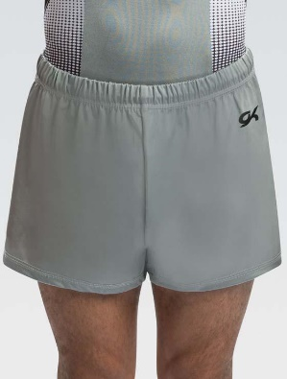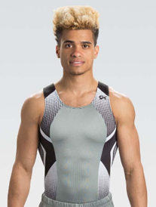

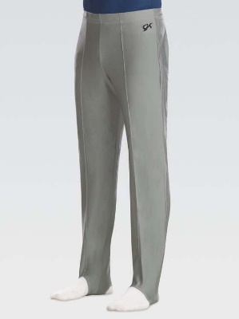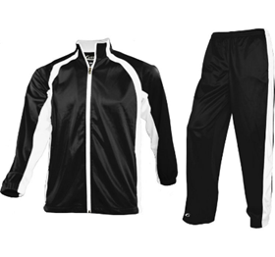

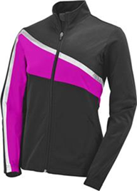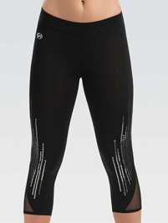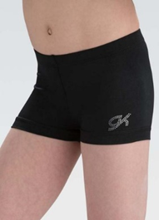

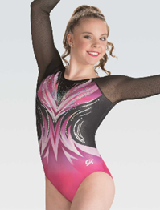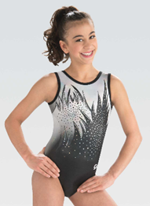

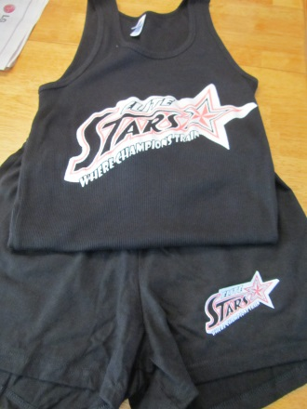

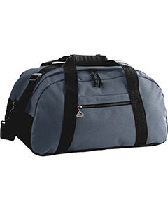

**Elite Stars Uniform Order 2018-19**

Athlete: Payment Amt:

Sport: Cash/Check #:

Please make checks out to: Pat D’Avolio

All team athletes are required to purchase the team warm up for competitions, events, outings & appearances.

***\*Some items are not available in YXL-in this case athletes will receive an AS***

|  |  |  |  |  |  |  |  |  |  |  |
| --- | --- | --- | --- | --- | --- | --- | --- | --- | --- | --- |
| **MALE DANCE/SKATING/GOLF** |  | **YS** | **YM** | **YL** | **YXL** | **AS** | **AM** | **AL** | **AXL** | **A2XL** |
| **Team T-Shirt/Tank** | **comp** |  |  |  |  |  |  |  |  |  |
| **Team Shorts—GIFT** | **comp** |  |  |  |  |  |  |  |  |  |
| **Team Bag—GIFT (if you don’t have one)** | **comp** |  |  |  |  |  |  |  |  |  |
| **Apex Warm Up Jacket & Pants** | **$75** |  |  |  |  |  |  |  |  |  |
| **Apex Warm Up Jacket Only** | **$40** |  |  |  |  |  |  |  |  |  |
| **FEMALE DANCE/SKATING** | **$75** | **YS** | **YM** | **YL** | **YXL** | **AS** | **AM** | **AL** | **AXL** | **A2XL** |
| **Team T-Shirt/Tank** | **comp** |  |  |  |  |  |  |  |  |  |
| **Team Shorts—GIFT** | **comp** |  |  |  |  |  |  |  |  |  |
| **Team Bag—GIFT (if you don’t have one)** | **comp** |  |  |  |  |  |  |  |  |  |
| **NEW Warm Up Jacket (set)** | **$75** |  |  |  |  |  |  |  |  |  |
| **NEW Warm Up Bottom Jeweled GK Capris** | **-------** |  |  |  |  |  |  |  |  |  |

|  |  |  |  |  |  |  |  |  |  |  |
| --- | --- | --- | --- | --- | --- | --- | --- | --- | --- | --- |
| **MALE GYMNAST** | **$80/155** | **YS** | **YM** | **YL** | **YXL** | **AS** | **AM** | **AL** | **AXL** | **A2XL** |
| **Apex Warm Up Jacket & Pants** | **$75** |  |  |  |  |  |  |  |  |  |
| **Apex Warm Up Jacket Only** | **$40** |  |  |  |  |  |  |  |  |  |
| **Team T-Shirt/Tank** | **comp** |  |  |  |  |  |  |  |  |  |
| **Team Shorts—GIFT** | **comp** |  |  |  |  |  |  |  |  |  |
| **Team Bag—GIFT (if you don’t have one)** | **comp** |  |  |  |  |  |  |  |  |  |
| **NEW Tank Leo (Grey)** | **$30** |  |  |  |  |  |  |  |  |  |
| **Competition Pants (Black)** | **$30** |  |  |  |  |  |  |  |  |  |
| **NEW Competition Shorts (Grey)** | **$20** |  |  |  |  |  |  |  |  |  |

|  |  |  |  |  |  |  |  |  |  |  |
| --- | --- | --- | --- | --- | --- | --- | --- | --- | --- | --- |
| **FEMALE GYMNAST** | **$175** | **YS** | **YM** | **YL** | **YXL** | **AS** | **AM** | **AL** | **AXL** | **A2XL** |
| **NEW Tank Leo** | **$35** |  |  |  |  |  |  |  |  |  |
| **NEW Long Competition** | **$50** |  |  |  |  |  |  |  |  |  |
| **NEW Warm Up Jacket (set)** | **$75** |  |  |  |  |  |  |  |  |  |
| **NEW Warm Up Bottom Jeweled GK Capris** | **-------** |  |  |  |  |  |  |  |  |  |
| **NEW Workout Spandex Shorts** | **$15** |  |  |  |  |  |  |  |  |  |
| **Team T-Shirt/Tank** | **comp** |  |  |  |  |  |  |  |  |  |
| **Team Shorts—GIFT** | **comp** |  |  |  |  |  |  |  |  |  |
| **Team Bag—GIFT (if you don’t have one)** | **comp** |  |  |  |  |  |  |  |  |  |

|  |  |  |  |  |  |  |  |  |  |  |
| --- | --- | --- | --- | --- | --- | --- | --- | --- | --- | --- |
| **FEMALE/MALE CHEER** |  | **YS** | **YM** | **YL** | **YXL** | **AS** | **AM** | **AL** | **AXL** | **A2XL** |
| **NEW Warm Up Jacket (set)** | **$75** |  |  |  |  |  |  |  |  |  |
| **NEW Warm Up Bottom Jeweled GK Capris** | **-------** |  |  |  |  |  |  |  |  |  |
| **Team T-Shirt/Tank** | **comp** |  |  |  |  |  |  |  |  |  |
| **Team Shorts—GIFT** | **comp** |  |  |  |  |  |  |  |  |  |
| **Team Bag—GIFT (if you don’t have one)** | **comp** |  |  |  |  |  |  |  |  |  |
| **FEMALE Cheer Skirt** |  |  |  |  |  |  |  |  |  |  |
| **FEMALE Cheer Shell** |  |  |  |  |  |  |  |  |  |  |
| **MALE Cheer Top** |  |  |  |  |  |  |  |  |  |  |
| ***Shoes & Bows are special order*** |  |  |  |  |  |  |  |  |  |  |